FANS Interoperability Team Meeting
(FIT/23)

Surfers Paradise, Australia
15th March 2016

Agenda Item [6]

CPDLC and ADS-C Data Link Performance Monitoring for the Brisbane FIR

Presented by Airservices Australia

SUMMARY

This paper presents Controller Pilot Data Link Communication (CPDLC) and Automatic Dependent Surveillance – Contract (ADS-C) from the Brisbane FIR as specified in the Global Operational Data Link Document (GOLD). Data was for the entire 2015 calendar year.

1. INTRODUCTION

1.1 This paper provides observed performance from the operational data link system in the Brisbane FIR. The purpose of this paper is to present the most recent observed performance for the period 1 January 2015 to 31 December 2015.

1.2 The performance data observed from the Controller Pilot Data Link Communications (CPDLC) and Automatic Dependent Surveillance - Contract (ADS-C) systems are measured against the appropriate Required Communication Performance (RCP) and Required Surveillance Performance (RSP) specification to demonstrate that safety objectives which rely on the communications infrastructure can be met by the aircraft and ground systems.

1.3 This paper presents the data link performance by media type and by operator with a break down by monthly performance

2. DISCUSSION

2.1 ADS-C Latency

2.1.1 Latency by month
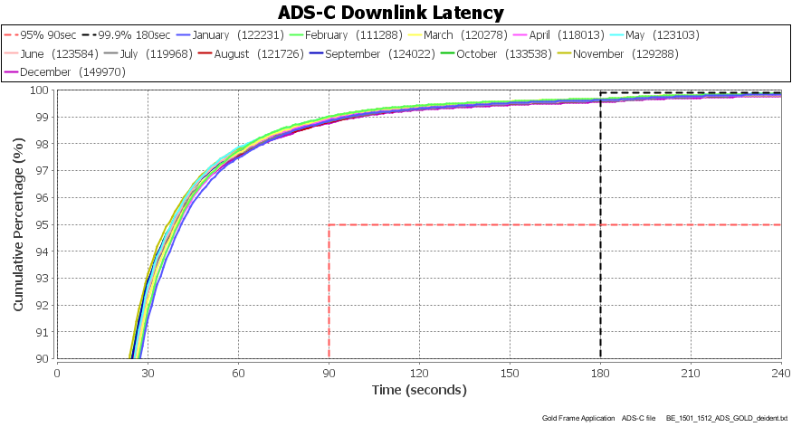
2.1.2 Latency by media

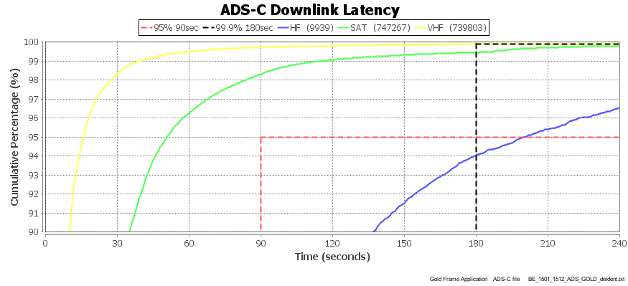

2.1.3 Latency by GES (with more than 10000 downlinks) – XXI is low

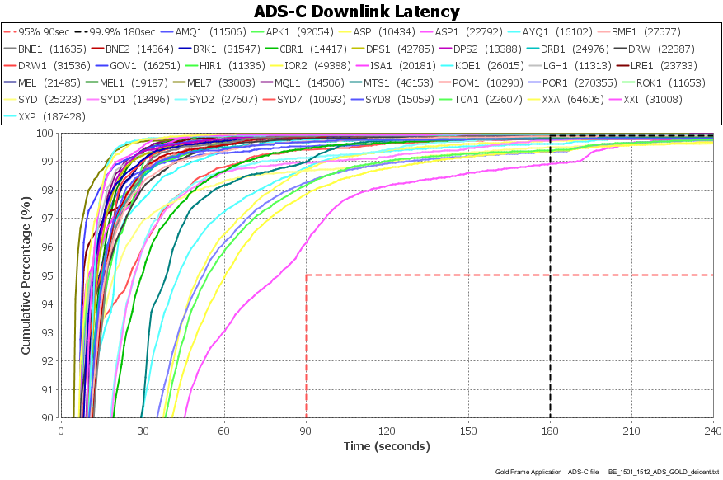

2.1.4 Latency by Satellite GES – IGW1 (yellow), IG1 (green) and XXI (red) are low

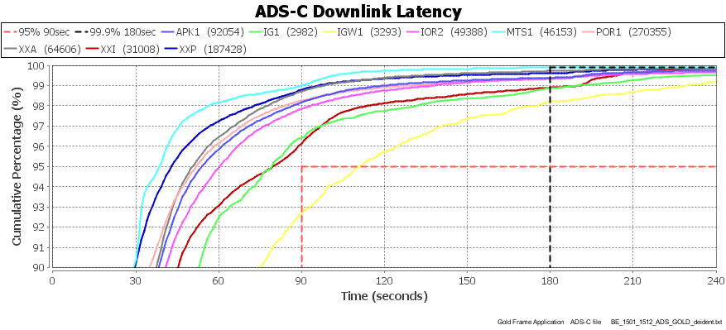

2.1.5 Latency for operators with more than 10000 downlinks - ?? (green) is relatively low

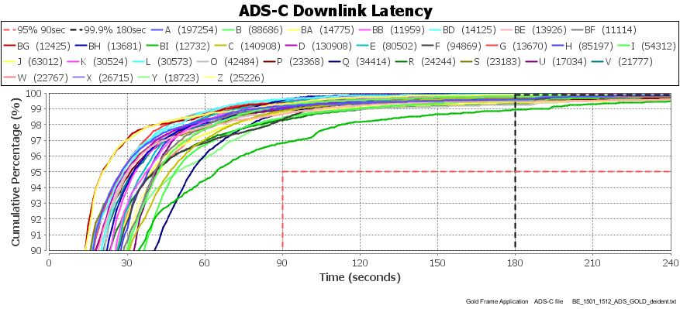

2.1.7 Latency for aircraft types with more than 10000 downlinks – MD11 is low

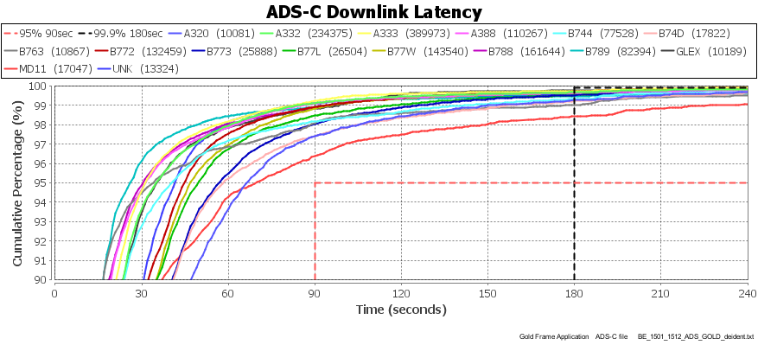

2.1.8 Latency for MD11 operators – BJ is low

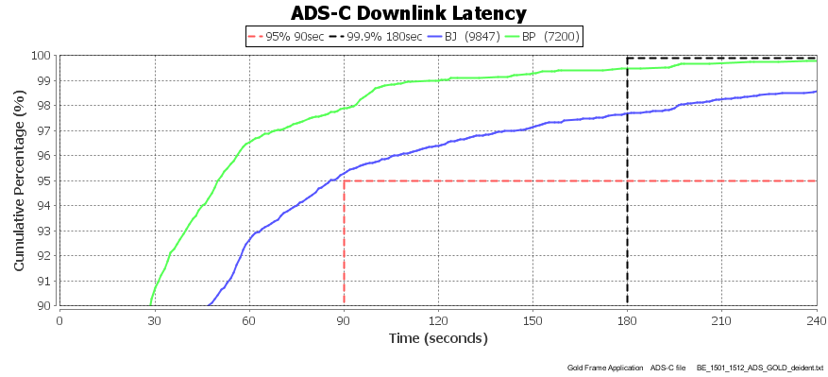

2.1.9 Latency for MD11 operator BJ by media

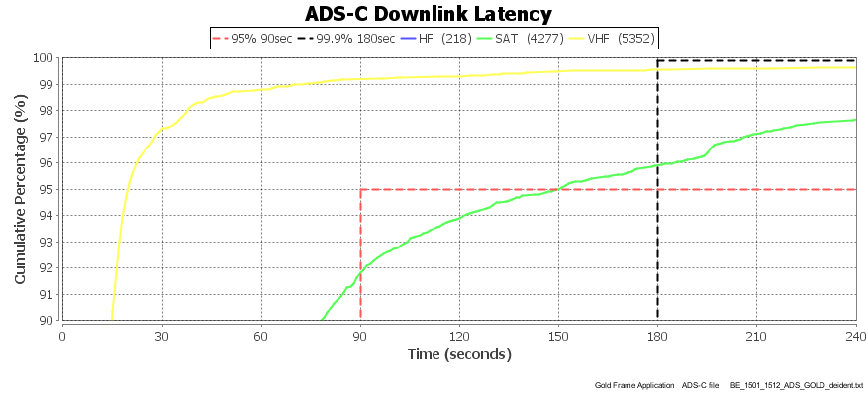

2.1.10 Latency for MD11 operator BP by media

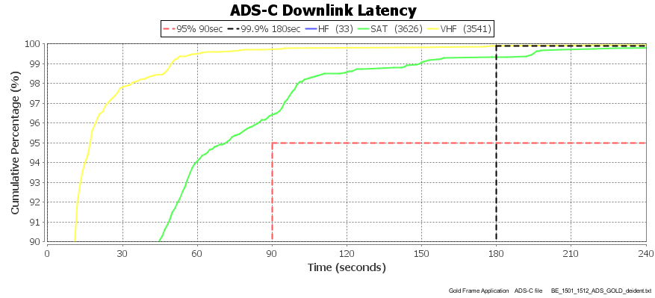

2.2 CPDLC ACP

2.2.1 CPDLC ACP by month
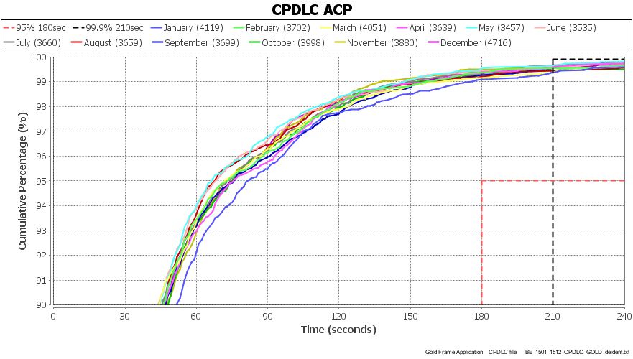

2.2.2 CPDLC ACP by media

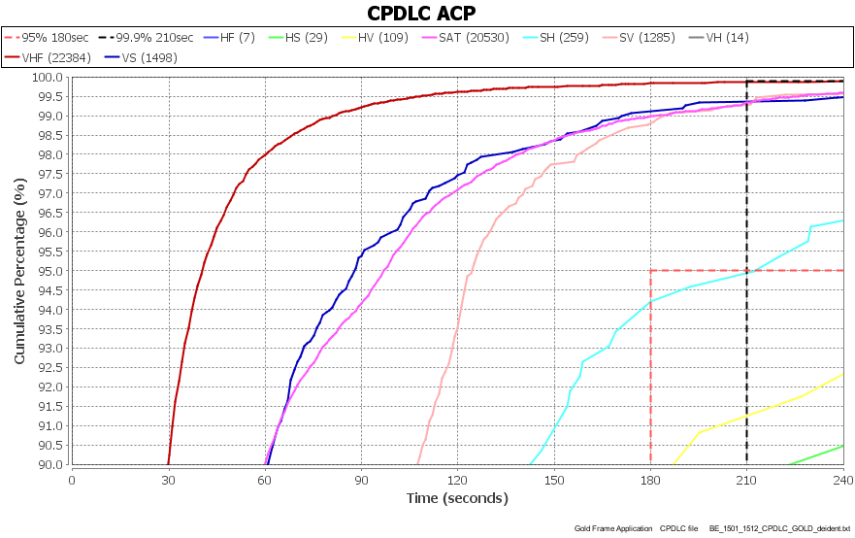

2.2.3 CPDLC ACP by GES with more than 1000 transactions

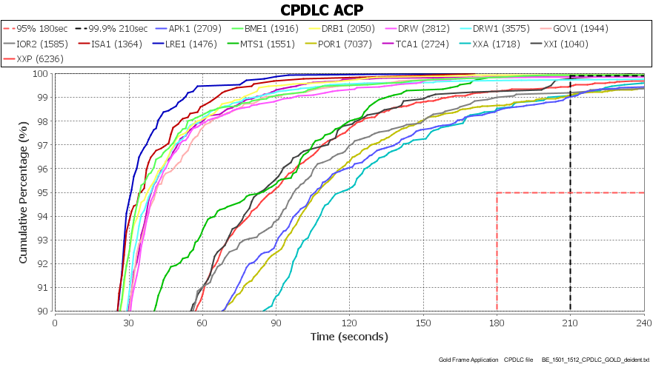

2.2.4 CPDLC ACP by satellite GES

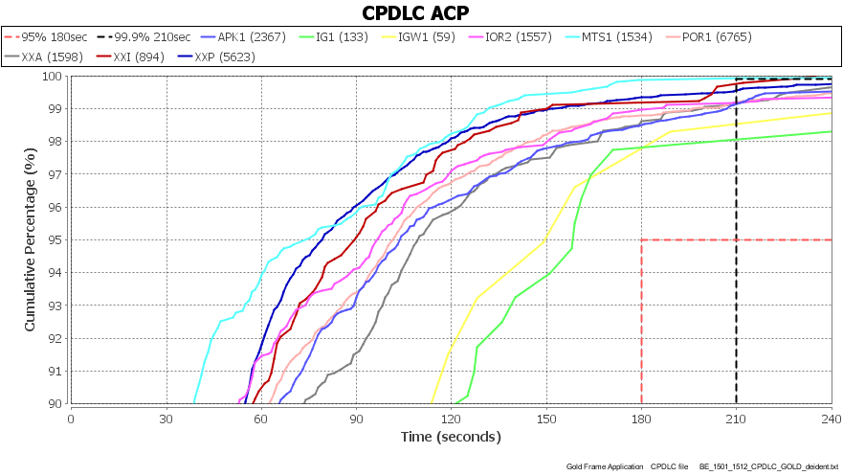

2.2.5 CPDLC ACP by operators with more than 1000 transactions

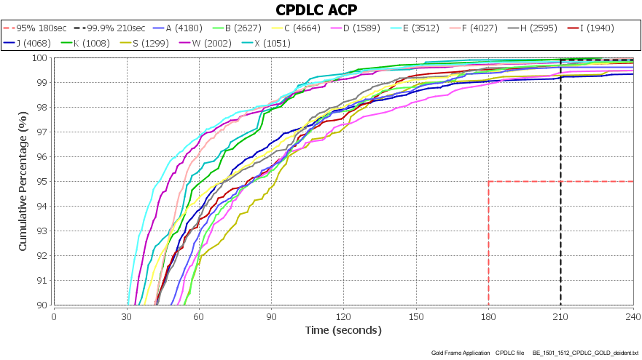

2.2.6 CPDLC ACP for bottom 9 operators with more than 10 transactions

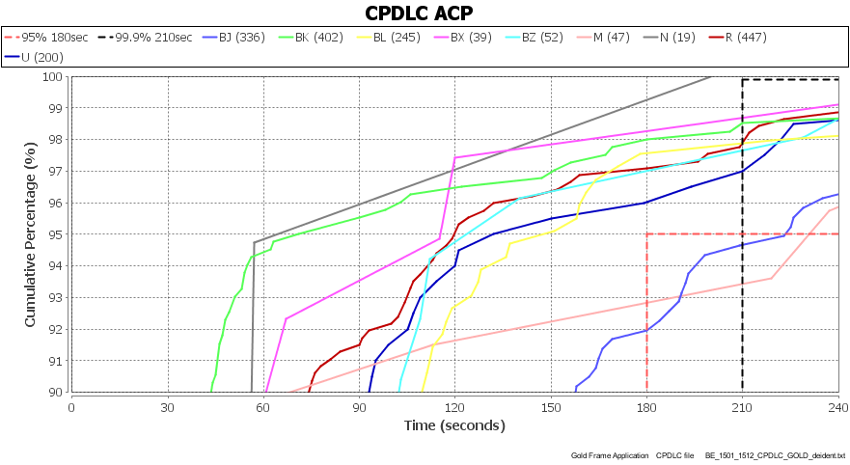

2.2.7 CPDLC ACP by aircraft type with more than 500 transactions – MD11 and B744 are low

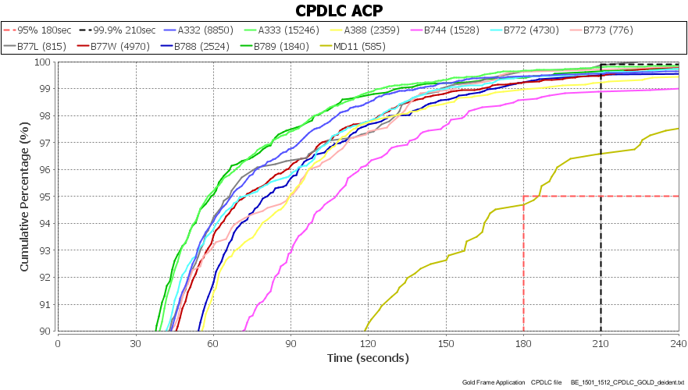

2.2.8 CPDLC ACP by B744 operator – a wide range of performance

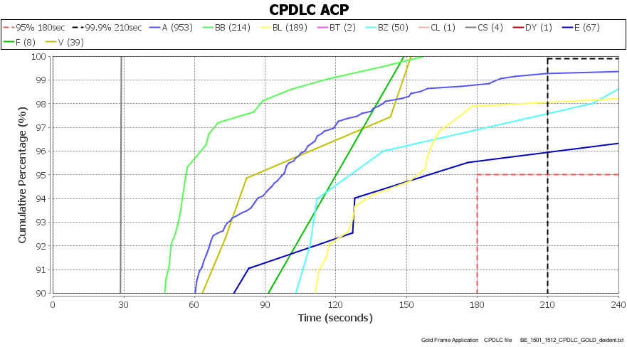

2.3 CPDLC ACTP

2.3.1 CPDLC ACTP by month

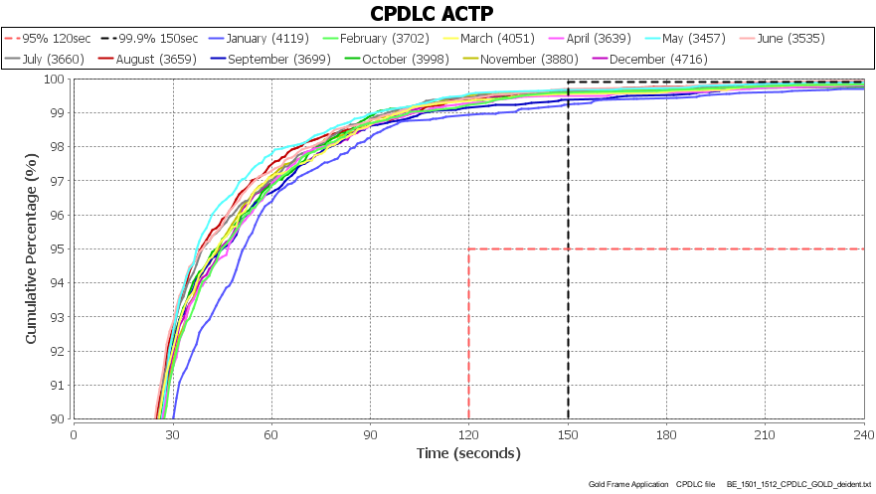

2.3.2 CPDLC ACTP by media

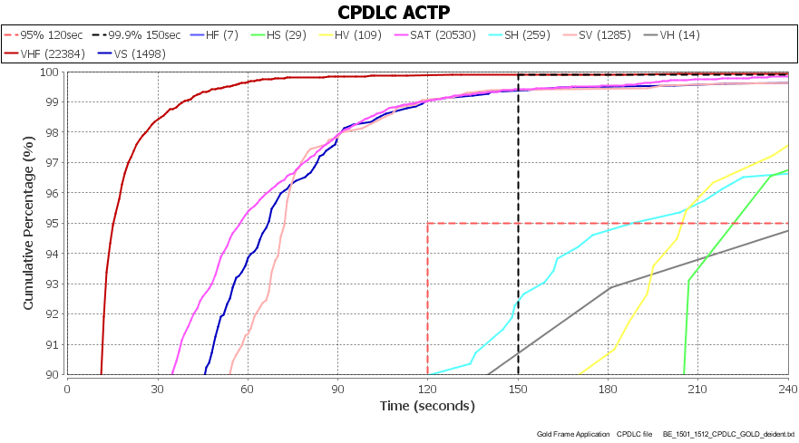

2.3.2 CPDLC ACTP by GES with more than 1000 transactions

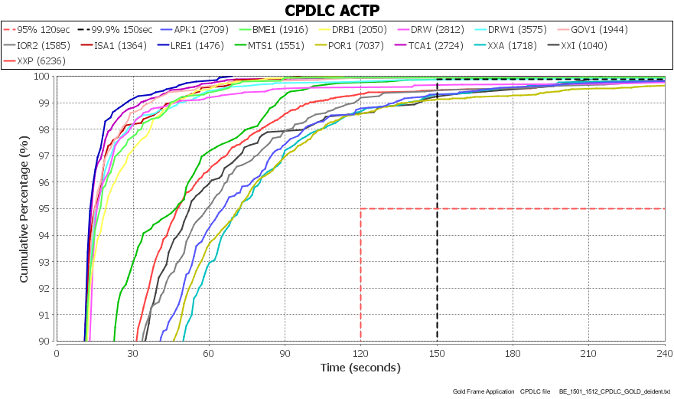

2.3.4 CPDLC ACTP by satellite GES

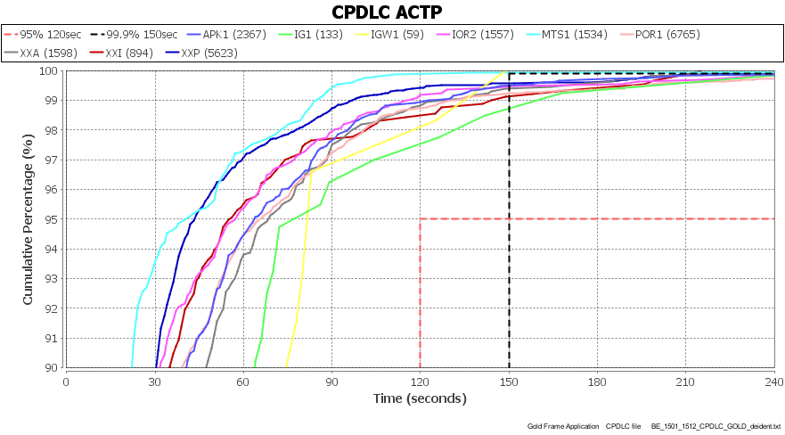

2.3.5 CPDLC ACTP by operators with more than 1000 transactions

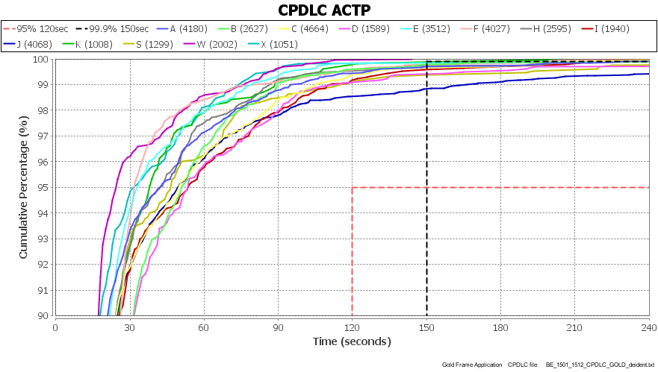

2.3.6 CPDLC ACTP by the bottom 9 operators with more than 10 transactions

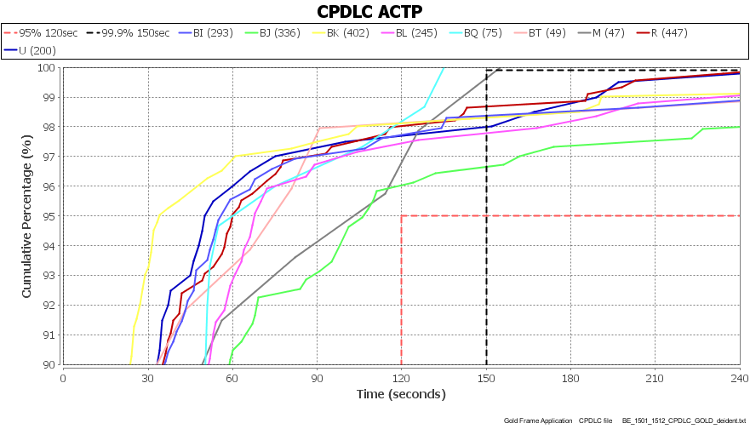

2.3.7 CPDLC ACTP by aircraft type with more than 500 transactions – MD11 is low

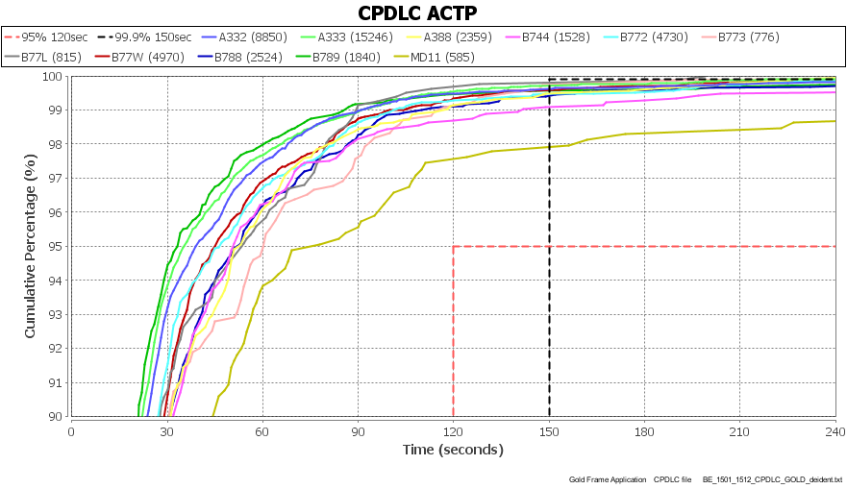

2.4 CPDLC PORT

2.4.1 CPDLC PORT by month

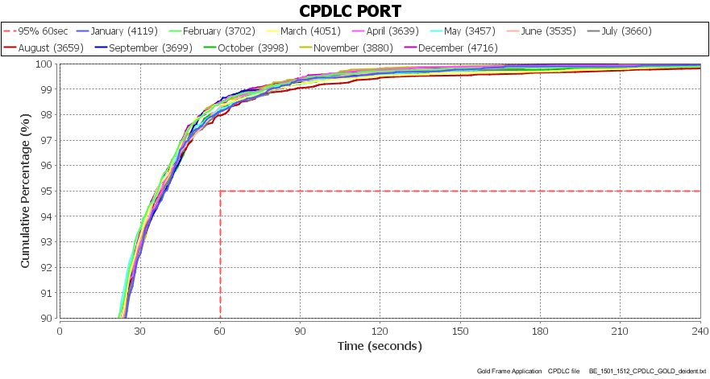

2.4.2 CPDLC PORT by media

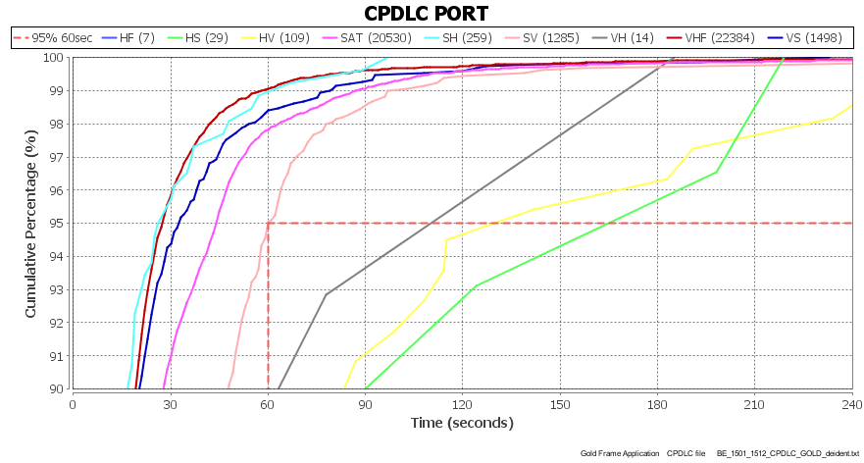

2.4.3 CPDLC PORT by GES with more than 1000 transactions

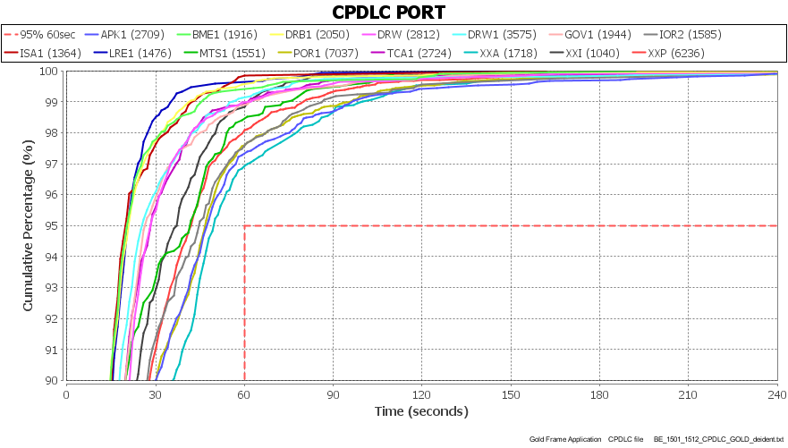

2.4.4 CPDLC PORT by satellite GES

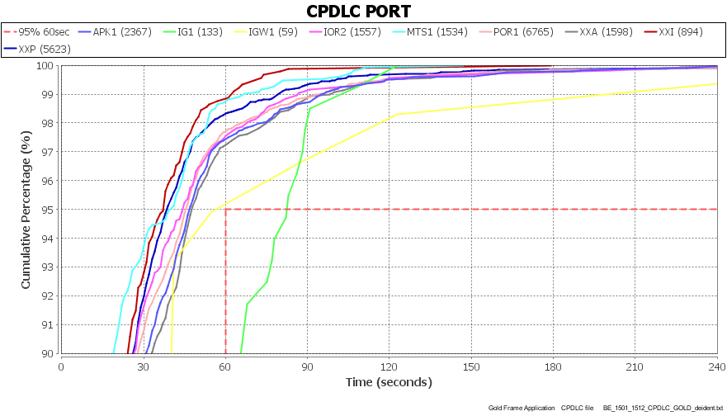

2.4.5 CPDLC PORT by operators with more than 1000 transactions

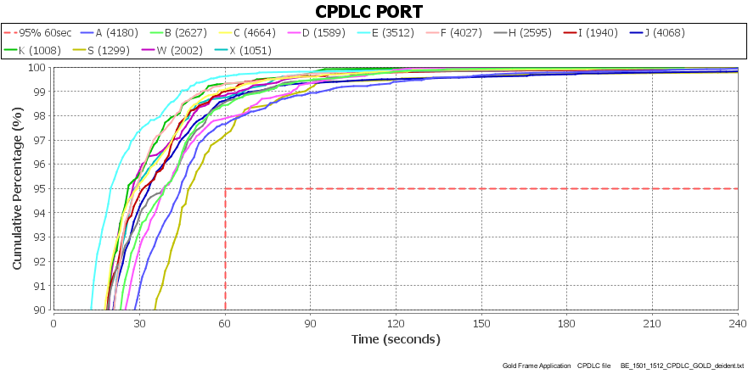

2.4.6 CPDLC PORT by bottom 8 operators with more than 10 transactions

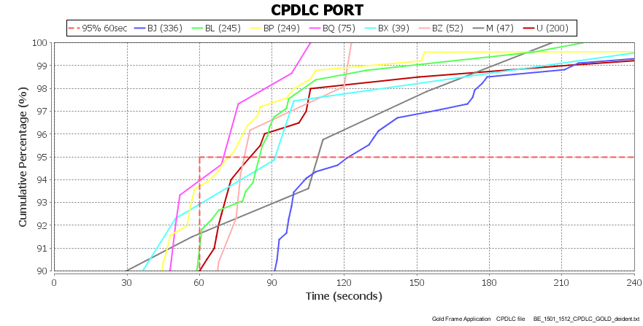

2.4.7 CPDLC PORT by aircraft types with more than 500 transactions – MD11 and B744 are low

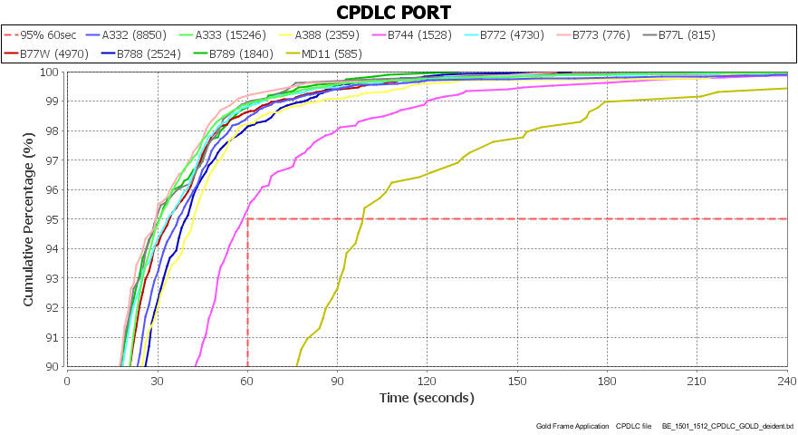

2.4.8 CPDLC PORT for B744 operators

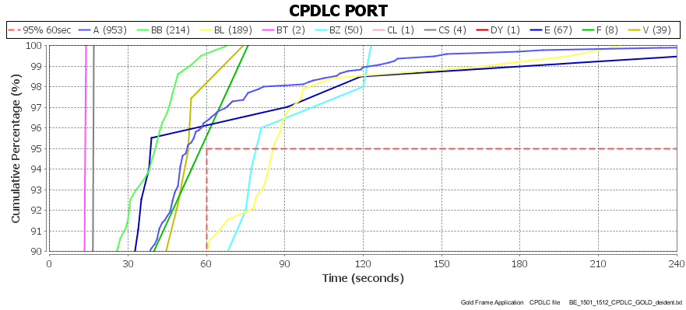

3. ACTION BY THE MEETING

3.1 The meeting is invited to:

a) Note the information in this Information paper

