FANS Interoperability Team Meeting
(FIT/23)

Surfers Paradise, Australia
15th March 2016

Agenda Item [5]

Use of UM42 by Australian ATC

Presented by Airservices Australia

SUMMARY

Support for UM42 and other uplink message elements has been discontinued by Airbus. This has the potential to impact CPDLC operations in Australia

1. INTRODUCTION

  - A recent FIT PR was submitted by Airservices Australia when it was discovered that on occasions the uplinking of UM42 to an Airbus aircraft resulted in an error message being downlinked.

  - Subsequent investigation revealed that this functionality had in fact been deliberately implemented by Airbus on the basis that this uplink message element (and others) had been recommended as “not to be used” by ICAO.

2. DISCUSSION

2.1 The following table contains the CPDLC uplink message elements that Airbus has advised they are no longer supporting. Some of these message elements are currently not available (via data adaptation) to controllers in Australia. The table also contains the Australian usage of these message elements in the period Feb 2015 to Jan 2016 inclusive:

UM | CPDLC message element | Airservices
 |  | Available | Usage  (YBBB, YMMM)
13 | AT [time] EXPECT CLIMB TO [altitude] | Y | 13,18
14 | AT [position] EXPECT CLIMB TO [altitude] | Y | 10,14
15 | AT [time] EXPECT DESCENT TO [altitude] | Y | 1,1
16 | AT [position] EXPECT DESCENT TO [altitude] | Y | 7,0
17 | AT [time] EXPECT CRUISE CLIMB TO [altitude] | N | 0
18 | AT [position] EXPECT CRUISE CLIMB TO [altitude] | N | 0
33 | CRUISE [altitude] | N | 0
40 | IMMEDIATELY STOP CLIMB AT [altitude] | Y | 0
41 | IMMEDIATELY STOP DESCENT AT [altitude] | Y | 0
42 | EXPECT TO CROSS [position] AT [altitude] | Y | 477,162
43 | EXPECT TO CROSS [position] AT OR ABOVE [altitude] | Y | 0
44 | EXPECT TO CROSS [position] AT OR BELOW [altitude] | Y | 0
45 | EXPECT TO CROSS [position] AT AND MAINTAIN [altitude] | Y | 1,0
175 | REPORT REACHING [altitude] | N | 0
178 | TRACK DETAIL MESSAGE | N | 0

2.2 While the usage of most of these message elements is non-existent or minimal, it can be seen that UM42 is commonly used. The following plots show the (approximate) positions of aircraft when UM42 was uplinked. The data was derived by cross-referencing the uplinking of UM42 with the closest previous position report (ADS-C or CPDLC) (up to a maximum of 20 minutes prior).
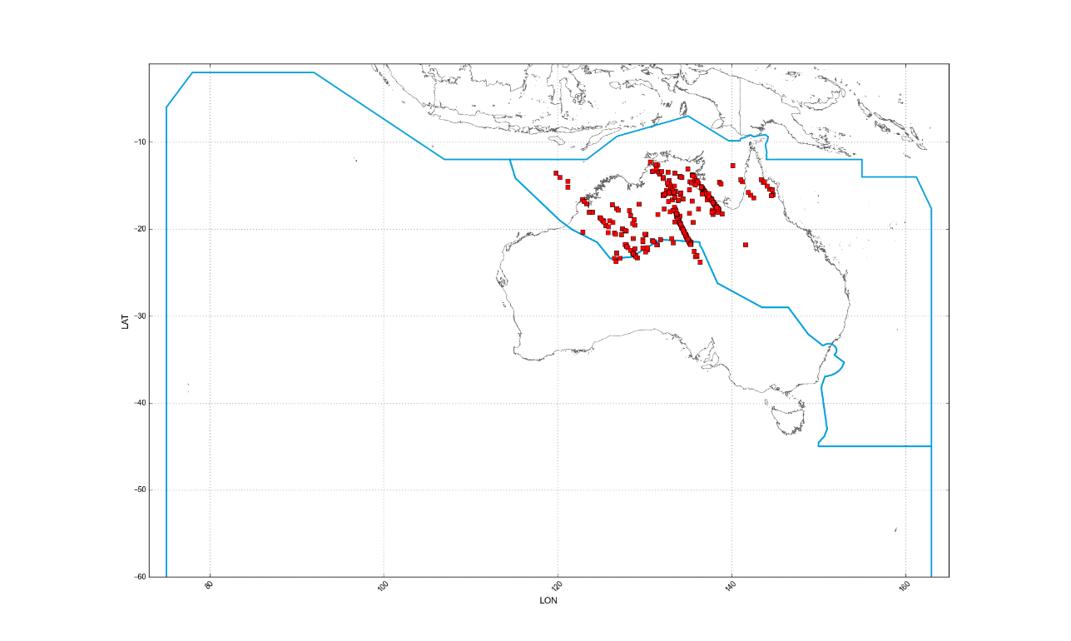
Fig 1. Use of UM42 by YBBB February 2015 to January 2016

2.3 Figure 1 shows the approximate position of 358 of the 477 UM42s uplinked by YBBB. The omitted messages are those for which no position report within the previous 20 minutes has been received.

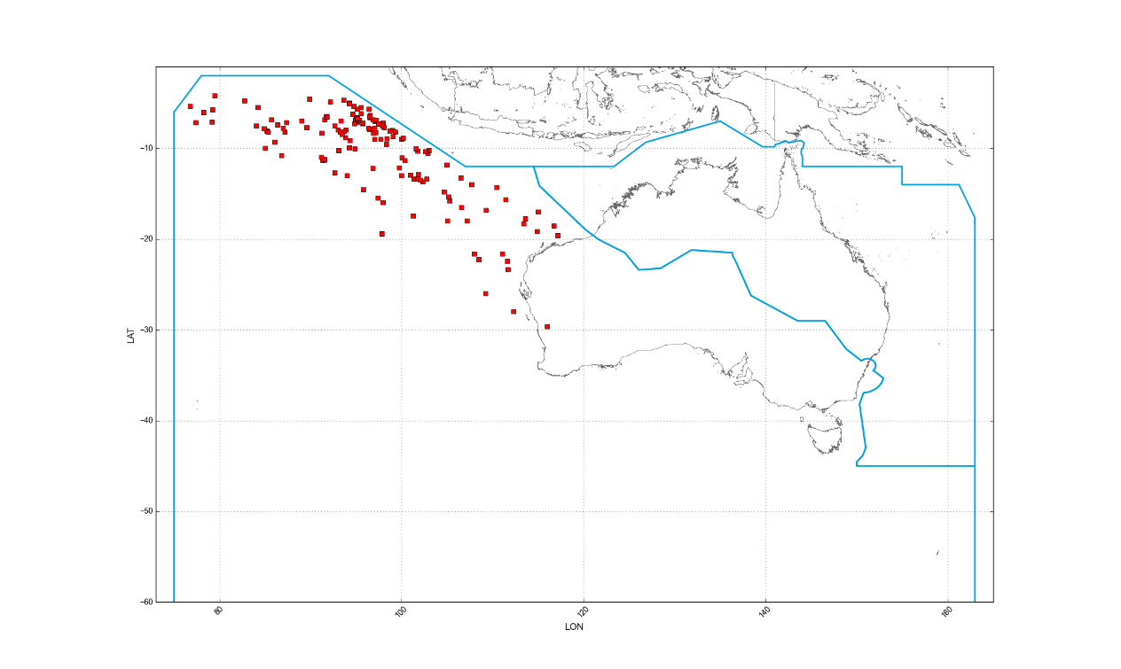
Fig 2. Use of UM42 by YMMM February 2015 to January 2016

2.4 Figure 2 shows the approximate position of 152 of the 162 UM42s uplinked by YMMM. The omitted messages are those for which no position report within the previous 20 minutes has been received

2.5 This message element is used extensively by some ATC Groups in Australia, typically for flights heading north-west to Makassar (by YBBB) and Colombo (by YMMM). This usage can be observed from the above data plots.

2.6 Due to the increased separation standards at the FIR boundaries to the north and north-west of Australia, level changes are often required by the FIR boundary for north bound aircraft. As these level changes can be in the order of 4000 feet or more, many controllers use UM42 to provide the flight crew with an expectation of what level they can expect crossing the FIR boundary.

2.7 As the support for these uplink message elements (primarily UM42) has been withdrawn by Airbus, possible options for Australian ATCs include:

- Continuing to use the message element with the knowledge that over time there will be an increasing number of instances of the message element being rejected (i.e. as aircraft are loaded with the new Airbus FANS software);

- Determining whether another CPDLC message element meets the operational requirements for which this message is currently used; or

- Using a free text message element to mimic the discontinued message element.

2.8 There are concerns that the removal of controller availability to UM42 (and other message elements) will result in a widespread increase in the use of non-standard free text to mimic the intent of UM42. This is clearly an undesirable outcome.

2.9 Various options for a standardized free text message element that have been discussed include:

- EXPECT A HIGHER (or “LOWER”) LEVEL AT (or “BEFORE”) [position]
- EXPECT REQUESTED (or “PREFERRED” LEVEL AT (or “BEFORE”) [position]

2.10 Further action to address this issue is pending input from FIT/ISPACG.

3. ACTION BY THE MEETING

3.1 The meeting is invited to:

a) Note the discontinued support of various CPDLC uplink message elements, and assess the impact on their own operations; and

b) Discuss options for processing north bound aircraft in Australia where significant level changes may be required, including the options for standardized free text.

