FANS Interoperability Team Meeting
(FIT/23)

Surfers Paradise, Australia
15th March 2016

Agenda Item 5 – Working Papers

Pilot initiated CPDLC Disconnections

Presented by Airservices Australia

SUMMARY

An initial analysis of pilot initiated CPDLC disconnections received by YBBB and YMMM indicates that these are not uncommon occurrences. This may have an impacts on ATC workload, and the transfer of ADS-C distance separation standards (e.g. 30NM, 50NM) across an FIR boundary. While further investigation is required, this working paper presents the initial observations.

1. INTRODUCTION

  - The original concept of CNS-ATM involved the “seamless transfer” of CPDLC connections across FIR boundaries. In theory, this allowed the transfer of a CPDLC connection without intervention by the flight crew.

  - While it was acknowledged that occasionally a CPDLC transfer may not be successful, thereby requiring flight crew intervention, this was expected to be an uncommon occurrence. Data analysis indicates, however, that flight crew initiated disconnections are not an uncommon event.

2. DISCUSSION

2.1 Data extracted from YBBB and YMMM shows that in October 2015, 732 pilot initiated CPDLC disconnections were received by YBBB and 2094 being received by YMMM.

2.2 The following diagrams depict the approximate locations where flight crew initiated CPDLC connections were received during October 2015. The data was derived by cross-referencing the receipt of DM62 (indicating a flight crew initiated disconnection) with the closest previous position report (ADS-C or CPDLC). Reports received within 20 minutes are displayed in red, and the less accurate data (> 20 minutes) are displayed in green.

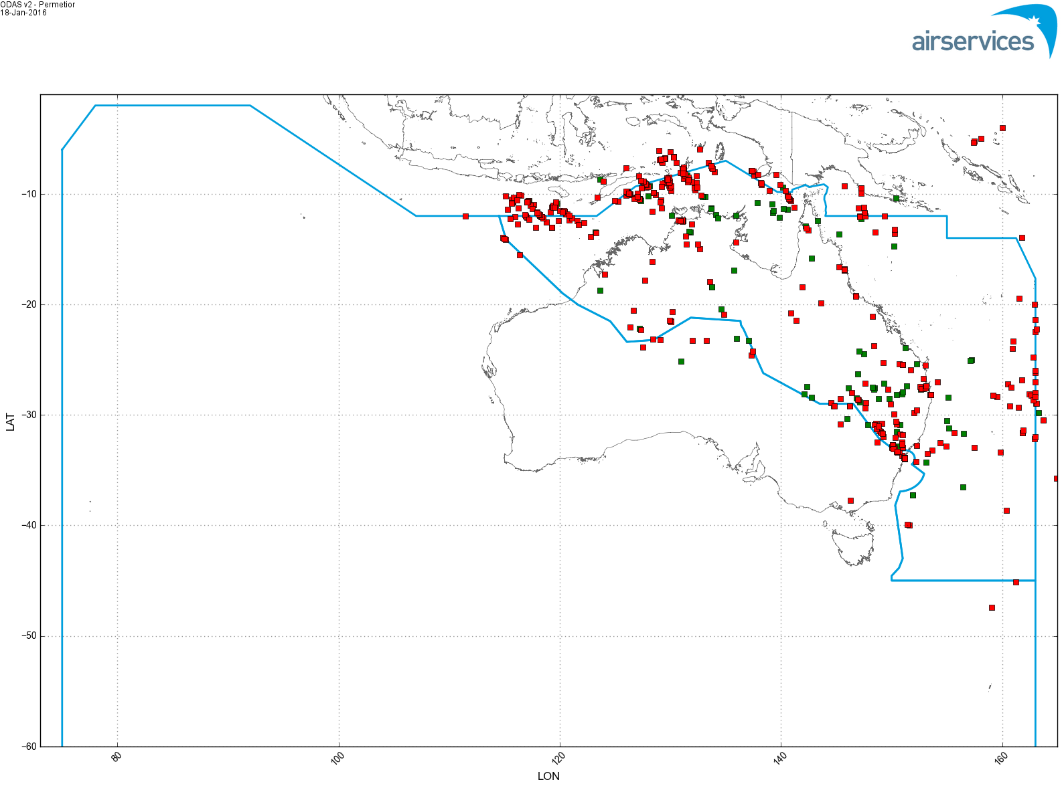

Figure 1. Receipt of DM62 (Pilot initiated disconnection) by YBBB October 2015
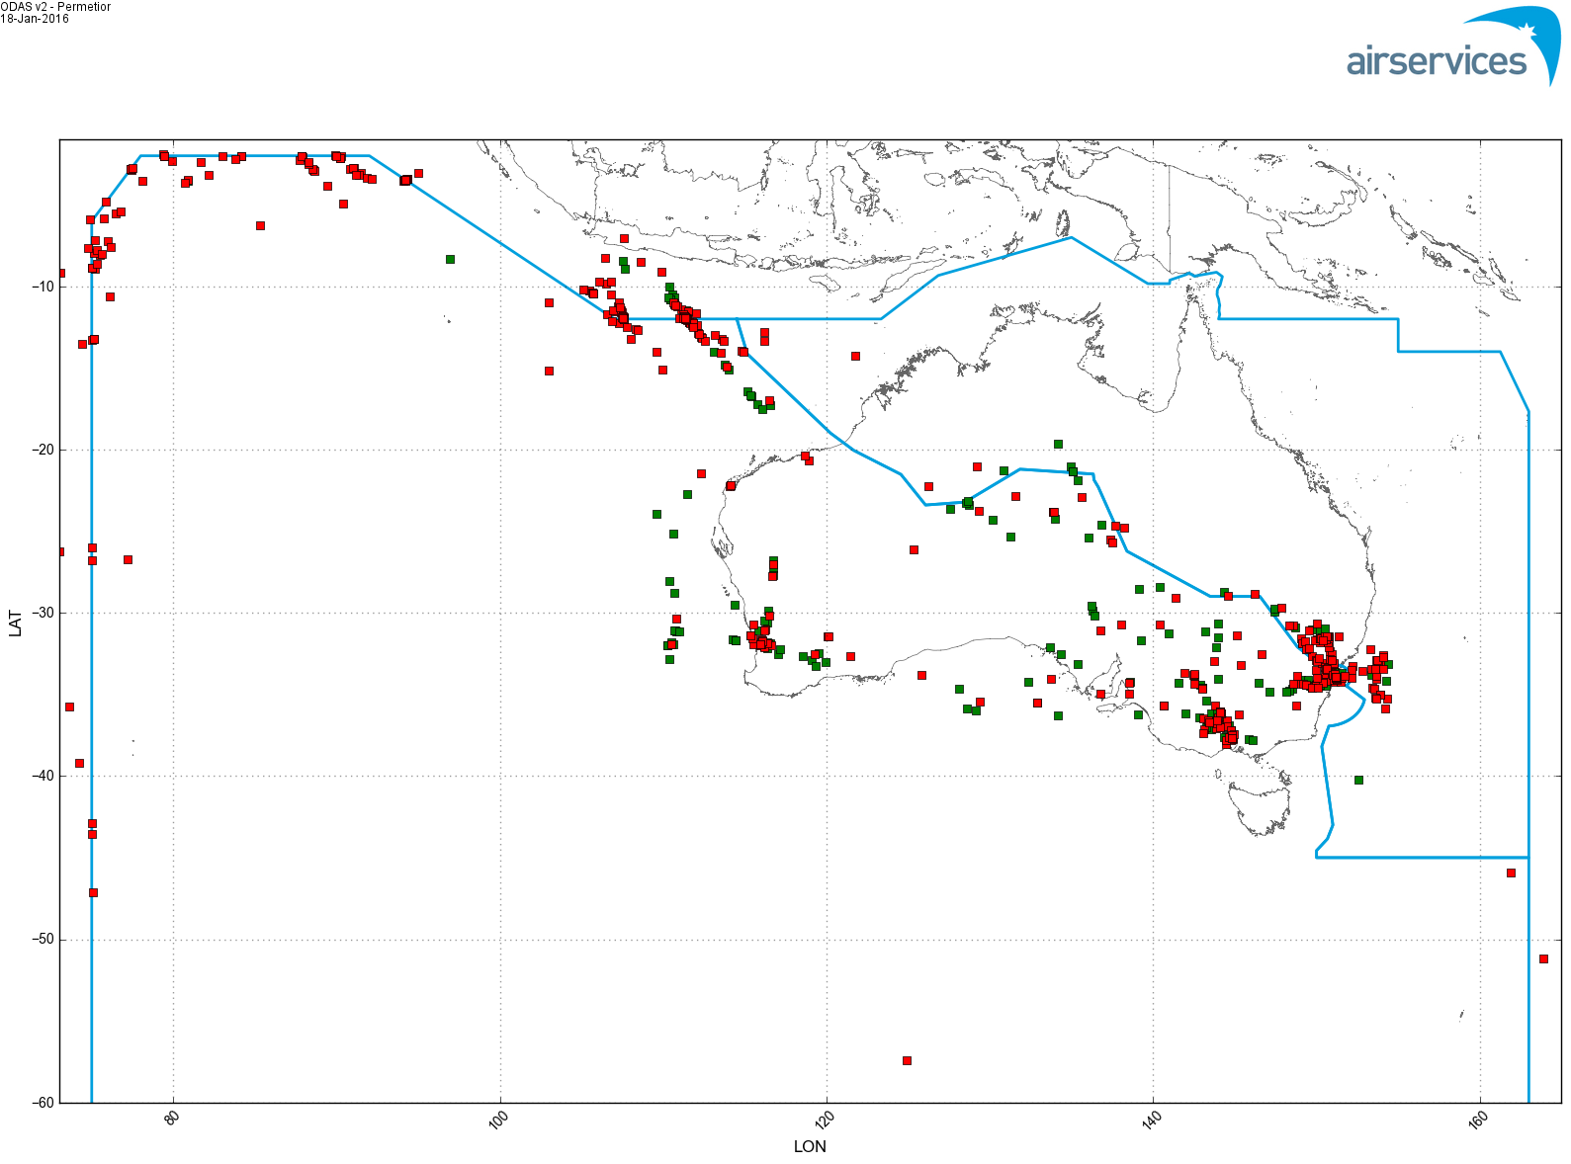
Figure 2. Receipt of DM62 (Pilot initiated disconnection) by YMMM October 2015

2.3 The following Table breaks down the receipt of these disconnections during October 2015 by aircraft type.

Type | YBBB | YMMM |  | Type | YBBB | YMMM
A320 | 2 | 1 |  | B772 | 20 | 47
A332 | 149 | 763 |  | B773 | 7 | 6
A333 | 221 | 545 |  | B77L | 32 | 33
A343 | 7 | 37 |  | B77W | 43 | 89
A388 | 71 | 220 |  | B788 | 32 | 23
B737 | 2 | 5 |  | B789 | 11 | 7
B738 | 38 | 6 |  | GL5T | 2 | 0
B744 | 71 | 180 |  | GLEX | 3 | 3
B748 | 2 | 7 |  | GLF5 | 1 | 5
B74D | 6 | 49 |  | GLF6 | 2 | 6
B763 | 3 | 13 |  | MD11 | 7 | 49
 |  |  |  | Total | 732 | 2094

Table 1. Breakdown of DM62 (Pilot initiated disconnection) per aircraft type

2.4 There are a number of reasons why a flight crew initiated CPDLC disconnection may occur, including:

- CPDLC transfer was unsuccessful. While there are ATC procedures to address this, sometimes flight crews take the initiative;

- Avionics software fault, causing the apparent loss of the CPDLC connection;

- Flight crews not following procedures, and attempting to control the CPDLC transfer

2.5 No rigorous analysis of this data has been conducted. However it is clear that:

- YMMM has a much higher incidence of receipt of DM62 (pilot initiated disconnection) than YBBB. It is believed that problems associated with CPDLC transfers for aircraft departing YSSY northbound may contribute to this discrepancy (the YBBB/YMMM FIR boundary is 45NM north of YSSY);

- Many of the displayed disconnections for YMMM are for routine disconnections for flights that have landed at YSSY, YMML and YPPH;

- A small number of aircraft types appear prominent in the data (A330, A388 and B744). It is unknown of this is indicative of a specific problem, or the high incidence is simply related to the number of these aircraft operating in the airspace

2.6 While the data needs to be filtered to provide a better indication of problems (e.g. filter the display of DM62s received from aircraft on the ground at YSSY), it is clear that problems exist at the FIR boundaries, especially to the north and north west of Australia where, for the most part, CPDLC transfers should be in place. While CPDLC transfer issues around YSSY can be readily solved on VHF (although it is a workload issue), resolving these problems can be more troublesome outside VHF coverage.

2.7 Many of the disconnections may be caused as a result of ATC and flight crews attempting to resolve CPDLC connection problems. Many FIT PRs have been raised on these problems.

2.8 Insofar as the ISPACG forum is concerned, the number of pilot initiated disconnections occurring between NFFF and YBBB needs to be addressed. From experience, it is believed that the majority of these disconnections are for westbound flights.

3. ACTION BY THE MEETING

3.1 The following action items are recommended:

a) Operators:- Ensure that flight crews are aware of regions where CPDLC transfers take place, and the procedures associated with CPDLC transfers

b) ANSPs:- Ensure that controllers are aware of procedures to resolve a failed CPDLC transfer

c) Avionics manufacturers:- Address software faults that cause CPDLC connection problems from occurring in the first place

Related information
Refer to Powerpoint “Transferring CPDLC connections” (run as a slide show)

