Thirty-Seventh Meeting of the
Informal South Pacific ATS Co-ordinating Group
(ISPACG/37)

Thirtieth Meeting of the FANS Interoperability Team (FIT/30)

Papeete, Tahiti
April 26, 2023

Agenda Item 8: Working Papers

Future Air Navigation System (FANS) Problem Report (PR) Briefing

Presented by the Central Reporting Agency (CRA)

SUMMARY

This paper describes recent investigation and disposition of submitted FANS PRs that are relevant to the ISPACG FIT.

- INTRODUCTION
  - FANS stakeholders may submit PRs for investigation via the http://www.fans-cra.com/ website.
    - Airways New Zealand graciously hosts and maintains this website.
    - Stakeholders from multiple areas use this website, including the South Pacific area (ISPACG FIT), the North and Central Pacific area (IPACG FIT), the Asia area (FIT-Asia), and the North Atlantic area (NAT TIG).
  - Between preparation of the previous FANS PR briefing for the FIT/29 meeting held in August 2022 and preparation of this FANS PR briefing in April 2023, FANS stakeholders submitted 98 PRs via the website, of which 21 PRs (21%) occurred in the South Pacific area. For comparison, the previous FANS PR briefing indicated that FANS stakeholders submitted 229 PRs, of which 19 PRs (8%) occurred in the South Pacific area.
  - Figure 1 illustrates the number of PRs that FANS stakeholders submitted per calendar year starting in 2006. The dotted line and associated number in the figure represent a linear projection of the number of PRs that will be submitted in 2023.
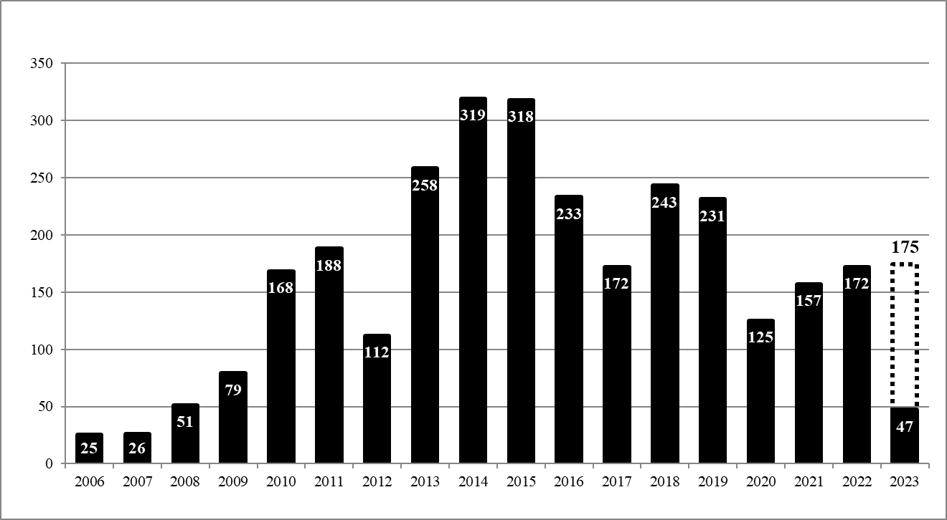
Figure 1 FANS PRs Per Year
  - PR status definitions include the following:
    - Raised: The PR originator submitted the PR but the CRA has not yet processed it.
    - Active: The CRA processed the PR and assigned it for investigation.
    - Open: The CRA completed the PR investigation but some form of corrective action is required before the CRA can close it..
    - Open – Fix Available: The appropriate stakeholder implemented corrective action and a fix is available for installation.
    - Closed: The appropriate stakeholder implemented corrective action.
    - Closed As Duplicate: The CRA is already tracking the same problem with another PR.
    - Closed – Monitoring: The CRA cannot determine the corrective action and will monitor future PRs for any recurrences of the problem.
  - PR type definitions include the following:
    - TBA: To be assigned
    - Air – Procedural: Flight crew issue
    - Air – Technical: Avionics issue
    - Ground – Procedural: Air traffic controller issue
    - Ground – Technical: ATS unit system issue
    - Network: Communication service provider or SATCOM service provider issue
    - Multiple: Multiple types of issues
    - None: Report is a non-problem
- DISCUSSION
  - Regarding updates to old PRs which are relevant to the ISPACG FIT, the CRA notes that some software updates to avionics on Boeing aircraft have become significantly delayed due to new cybersecurity requirements for certification. While Boeing expects 757/767 Pegasus I BP11 software (which will resolve PRs 1516-GS and 2123-GS) to become available in June 2023, it does not expect 747 NG FMC BP4.1 (which will resolve PRs 2892-KS, 3119-MM, and 3251-GM) to become available until Q2 2024 and 777 AIMS BPV18 (which will resolve PRs 2292-SN, 2821-SH, and 3090-SH and also implement the RAT1 timer) to become available until Q3 2024.
  - The CRA received the following significant new PRs which occurred in the South Pacific region:
    - 3452-MM, Closed – Monitoring / TBA. Airways New Zealand reported that a Dassault Falcon 7X did not meet PBCS 95% normal operating requirements. ACARS message log analysis by the CRA of nine of the reported events indicated that eight of them occurred due to evident losses of SATCOM that each lasted about three minutes when the airplane was between New Zealand and Australia. Satcom Direct (the aircraft operator's flight support services provider) performed SATCOM system and configuration checks but did not find any problems. Airways New Zealand indicated that more recent performance meets PBCS 95% normal operating requirements and recommended that the PR be placed in the Closed – Monitoring state.
    - 3459-MM, Closed / None. An Air New Zealand Boeing 787 flight crew reported that a CPDLC transfer of authority from Tahiti to Oakland Oceanic failed. ACARS message log analysis by the CRA indicated that the transfer failed because Tahiti attempted to perform the transfer when it was still the NDA. When Tahiti did become the CDA, however, it did not perform AFN address forwarding to Oakland Oceanic again to trigger it to establish a CPDLC connection as the NDA. Tahiti indicated that the failure was unavoidable because this was a short sector transit (only 12 minutes in its airspace) and Air New Zealand concurred with closing the PR.
    - 3460-MM, Closed / Air – Technical. A Boeing 787 flight crew reported that a temporary loss of ACARS communications resulted in termination of a CPDLC connection with Oakland Oceanic. ACARS message log analysis by the CRA confirmed that ACARS communications with the aircraft were lost during the period in question, although Boeing could not determine the cause for the loss because avionics logs for that period were no longer available, in turn because the PR was submitted almost two months after the problem occurred. The CRA encourages stakeholders to submit PRs as soon as practical and has closed this PR.
    - The CRA received two PRs for FANS uplink messages that aircraft failed to receive when they had no ACARS communications while their Inmarsat SATCOM avionics were switching between satellites. Considering that this behavior is by design, the CRA recommends that ATS providers resend failed FANS uplink messages one time after waiting for about two to three minutes (in part to follow ICAO Doc 4444 Section 14.3.8 guidance). The CRA has closed these PRs as duplicates of PR 1344-MM and notes that this behavior is documented as problem G5 in the FANS Problem-Solution Tracker (available at https://www.fans-cra.com/performance/list/all_regions). The CRA also notes that ATS providers which resend failed FANS uplink messages one time are experiencing increased uplink message success rates.
      - 3464-RA, Closed as Duplicate / Ground – Technical. Airways New Zealand reported that a Kalitta Air Boeing 777 failed to receive a CPDLC climb clearance. The CRA determined that the failure occurred when the aircraft had no ACARS communication while its Inmarsat SATCOM avionics were switching between satellites and closed this PR as a duplicate of PR 1344-MM.
      - 3473-MM, Closed as Duplicate / Ground – Technical. Airways New Zealand reported that an Air New Zealand Boeing 787 failed to receive a CPDLC weather deviation clearance. The CRA determined that the failure occurred when the aircraft had no ACARS communication while its Inmarsat SATCOM avionics were switching between satellites and closed this PR as a duplicate of PR 1344-MM.
    - 3478-MM, Closed / None. NiuSky Pacific reported that it received a "WAGDP_CPDLC_DOWNLINK_INCORRECT_REFERENCE" warning. ACARS message log analysis by the CRA indicated that the aircraft, a Jetstar Boeing 787, sent a dM0 WILCO downlink first via VHF and then again via SATCOM because the aircraft did not believe that the downlink was delivered successfully via VHF when it was in the process of exiting VHF datalink coverage. Port Moresby sent a uM159 ERROR unrecognizedMsgReferenceNumber uplink in response to the second downlink that it received via SATCOM, which correlates to the reported warning. The CRA closed this PR as a non-problem on the basis that the aircraft correctly rerouted the downlink to SATCOM according to the ACARS protocols and that occasional duplicate downlinks are an unavoidable consequence of mobile RF (wireless) data communications. The CRA also recommends that ATS providers consider detecting and discarding duplicate downlinks like avionics detect and discard duplicate uplinks; please see ICAO Doc 10037 (GOLD) 1st Edition Section 1.2.1.1.5 (including Note 1) and Appendix C.20 as well as problem G6 in the FANS Problem-Solution Tracker (available at https://www.fans-cra.com/performance/list/all_regions).
    - 3486-RA, Active / Air – Technical. Airways New Zealand and the FAA reported that they observed several Boeing 777s operated by the same aircraft operator to simultaneously use both Inmarsat SATCOM and Iridium SATCOM, which resulted in poor ACP (because uplink messages evidently succeeded only via Iridium SATCOM) as well as duplicate ADS-C reports (because the avionics transmitted the reports via both Inmarsat SATCOM and Iridium SATCOM). On the basis that the aircraft operator added the Iridium SATCOM avionics installation, the CRA assigned the operator to investigate this PR further.
    - 3491-CJ, Active / TBA. A Royal Australian Air Force Dassault Falcon 7X flight crew reported issues logging on to YMMM and YBBB. The crew reported an inability to establish a CPDLC connection (ATC COMM ESTABLISHED was never displayed). This PR is believed to be a duplicate of 3180-MM and 3279-MM. PR 3180-MM has been designated as a master PR for this issue. The CRA assigned this PR to Honeywell for investigation.
    - 3511-MM, Active / TBA. An Air New Zealand Boeing 787 flight crew reported that they received eleven MONITOR uplinks during an eight-minute period. The CRA assigned the ATS provider to investigate this PR further.
  - The CRA received the following significant new PRs which occurred outside the South Pacific region but which are relevant to the ISPACG FIT:
    - The CRA received several PRs (3347-MM, 3371-MM, 3449-RA, and 3481-RA) caused by ATS providers incorrectly considering a dM40 ASSIGNED ROUTE [routeclearance] downlink containing a legal “-” (hyphen) character in the approach procedure name (e.g., “ILS-Y”) to be an error. ATS providers should consider confirming that their systems accept all legal characters, which per RTCA DO-258A / EUROCAE ED-100A for a departure, arrival, or approach procedure name is the “IA5String” (ASCII) character set defined in the ITU T.50 standard (available at https://www.itu.int/rec/T-REC-T.50-199209-I/en).
    - The CRA received several PRs (3411-CJ, 3455-CJ, 3470-RA, and 3471-MM) for uM79 CLEARED TO [position] VIA [routeclearance] uplinks that when loaded caused the avionics to remove the arrival, arrival transition, and/or approach from the route. Boeing confirmed that inclusion of the destination airport parameter in a uM79 uplink causes the avionics to remove the arrival, arrival transition, and/or approach from the modified route because the avionics reload the destination airport, even if the destination airport in the uplink is the same as the destination airport in the active route. Boeing accordingly recommends that ATS providers refrain from including the destination airport parameter in a uM79 uplink.
    - The CRA also shares the following two general observations, which are not limited to the South Pacific area but are global in nature:
      - Some organizations which the CRA assigns to investigate PRs do not investigate the PRs, even after reminders from the CRA. Some of these organizations are PBCS Charter stakeholders, despite the charter’s statement that all stakeholders should “Support problem investigations upon CRA request.”
      - The CRA has recently received a number of PRs in various areas around the world (including the South Pacific) that were evidently caused by problems with aftermarket avionics that aircraft operators installed without aircraft manufacturer involvement. In these cases, the responsibility to investigate and resolve the problems is primarily on the aircraft operator and its avionics supplier.
  - The CRA received the following less-significant new PRs which occurred in the South Pacific region:
    - 3438-MM, Active / TBA. Airservices Australia reported that in a seven-minute period it received 33 AFN contact messages containing a position at an airport in the western continental United States from a Bombardier Challenger 604. The CRA could not determine whether the flight crew manually generated the messages or the avionics automatically generated them and assigned Bombardier to investigate the PR.
    - 3440-MM, Active / TBA. NiuSky Pacific reported that AFN address forwarding with a China Airlines Airbus A350 failed. The CRA assigned Airbus to investigate this PR. Please refer to the Airbus PR briefing for details regarding this PR.
    - 3441-CW, Active / TBA. Air New Zealand reported a non-conforming ADS-C report from an Airbus A320. The CRA assigned this PR to Airbus to investigate. Please refer to the Airbus PR briefing for details regarding this PR.
    - 3442-NI, Active / TBA. Airways New Zealand reported consecutive ADS-C downlink delays with an Air New Zealand Airbus A321 utilizing Iridium media. The CRA assigned this PR to Airbus to investigate. Please refer to the Airbus PR briefing for details regarding this PR.
    - 3445-NI, Active / TBA. NiuSky Pacific reported multiple ADS-C disconnects with a Qantas Airbus A330. The CRA assigned this PR to Airbus to investigate. Please refer to the Airbus PR briefing for details regarding this PR.
    - 3466-MM, Closed / TBA. NiuSky Pacific reported that it received an incorrect ADS-C position report from a Jetstar Boeing 787. ACARS message log analysis by the CRA and avionics log analysis by Honeywell did not confirm the reported problem, however. Due to a loss of ACARS communications, the aircraft actually transmitted the last ADS-C report almost 45 minutes before the time of the reported problem.
    - 3468-CJ, Active / TBA. NiuSky Pacific reported an inability to establish an ADS-C connection with a Qantas Airbus A330. The CRA assigned this PR to Airbus to investigate. Please refer to the Airbus PR briefing for details regarding this PR.
    - 3469-CJ, Active / TBA. NiuSky Pacific reported intermittent issues establishing CPDLC and ADS-C connections with a China Airlines Airbus A350. The CRA assigned this PR to Airbus to investigate. Please refer to the Airbus PR briefing for details regarding this PR.
    - 3474-CJ, Active / TBA. Airservices Australia reported receiving duplicate CPDLC downlink requests from China Airlines A330 and A350 aircraft. The CRA assigned this PR to Airbus to investigate. Please refer to the Airbus PR briefing for details regarding this PR.
    - 3476-MM, Active / TBA. An Air New Zealand Airbus A321 flight crew reported that they were unable to send CPDLC messages. The CRA assigned Airbus to investigate this PR. Please refer to the Airbus PR briefing for details regarding this PR.
    - 3489-MM, Active / TBA. NiuSky Pacific reported that it lost an ADS-C connection with a Qantas Airbus A330. The CRA assigned Airbus to investigate this PR. Please refer to the Airbus PR briefing for details regarding this PR.
    - 3496-RA, Closed as Duplicate / Air – Technical. The FAA reported that it received many apparently duplicate AFN contact messages from Qantas and Philippines Airlines Airbus A330s. The CRA closed this PR as a duplicate of PR 3480-RA, which Airbus is currently investigating.
- ACTION BY THE MEETING
  - The CRA invites the ISPACG FIT to:
    - note the content of this paper; and
    - promote expeditious resolution of Active and Open PRs.

