**ISPACG/37 Plenary**

**Summary of Discussion and Action Items**

Tour de Contrôle Aérien, Faaa, French Polynesia

27 April 2023

1. **Opening Remarks**

The 37th meeting of the ISPACG Plenary was held on 27 April 2023 at the Tour de Contrôle Aérien, Faa’a, French Polynesia. ISPACG Co-chairs, Asia Pacific Manager, Air Traffic Organization (ATO) International, Ahmad Usmani, and Airway New Zealand’s Oceanic Operations Team Leader, Todd Kendall, welcomed the participants and thanked Nicholas Hinchliffe of Tahiti for hosting this year’s meeting in person. The meeting was attended by 29 participants (Attachment A) and started with a quick introduction of participants and review of the agenda.

All papers presented to the meeting are available and posted on the ISPACG website under the Plenary tab. Supporting documents are attached in Attachment B of this report.

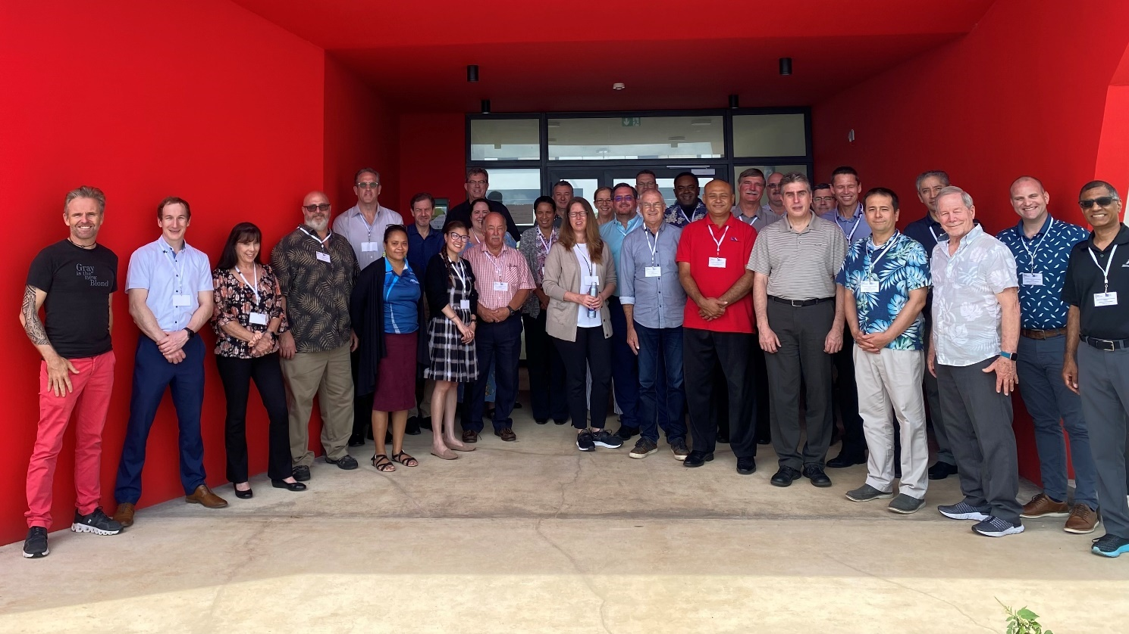

1. **Facility Updates from ANSPs**
   1. DGAC Chile – Gustavo Caceres

*Refer to presentation paper posted on the ISPACG website.*

**Q:** An operator asked if it was possible to DARP in the Santiago FIR?

**A:** Chile replied that they are working on it but do not currently have the capability.

* 1. Airways New Zealand – Todd Kendall and Trevor Land

*Refer to presentation slides posted on the ISPACG website.*

**Q:** When an Operator needs a deviation over 128 miles, is there any possibility to obtain a deviation clearance for that, or is it a reroute?

**A:** It will be a reroute. It was explained that the 128 NM was a limit of the CPDLC deviation clearance element.

**Q:** What is the significance of PBCS-approved aircraft or non-PBCS-approved aircraft in the airspace?

**A:** Controllers will apply the separation minima applicable to the aircraft’s capabilities.

* 1. NiuSky Pacific – Doku Iru and Freesia Wavine

*Refer to presentation slides posted on the ISPACG website.*

* 1. FAA Oakland Center (ZOA) – Holly King

*Refer to presentation slides posted on the ISPACG website.*

**Q:** Is there any way to get the ITP clearance request message pre-formatted to minimize rejections of ITP requests due to formatting errors?

**A:** No clear answer was provided regarding ITP preformatted requests. It is a function of the aircraft FMS of which there are many variations. Operators requested for Holly to share via email the ITP request table that ZOA created to help with the ITP clearance request rejections.

**Q:** What is the staffing level for Oakland oceanic?

**A:** PAC South is at 32 Certified Professional Controllers (CPC). PAC North is at 23 CPCs but will lose two CPCs soon due to retirement.

* Airways NZ echoed the statement on staffing, adding that they currently have 31 FTEs and really need 36-37 FTEs. Although there are new hires coming on-board, it will take some time due to training, and they will likely lose some in the training process.
  1. Airservices Australia

*No presentation / not in attendance*

* 1. SEAC-PF – Nicolas Hinchliffe

*Refer to presentation slides posted on the ISPACG website.*

* Specific to Tahiti, they have only one ADS-B receiver in operation at this time, France relies primarily on secondary radar for surveillance.

**Q:** Is there room for a taxiway to be built at Papeete?

**A:** No, there isn’t room. Papeete only has the single runway and no ground controller position.

* 1. Fiji Airports – Veniona Toga & Ivan Wong

*Refer to presentation slides posted on the ISPACG website.*

1. **Industry Updates**
   1. IATA

*No presentations / not in attendance*

* 1. Operators
     1. American Airlines – Steve Smith and Wayne Snyder

*Refer to presentation slides posted on the ISPACG website.*

* AAL expressed concern about late notification for NOTAM cancellation. This applies to both military activities and commercial space operations as follows:
  + Often, they could tell that an activity or exercise would be cancelled due to weather, but NOTAM cancellation would not take place until 2-3 hours before the scheduled activity.
  + Furthermore, regarding the cancellation of NOTAMs with a neighboring FIR, the NOTAM might have been cancelled in a timely manner, but the neighboring FIR’s NOTAM will remain active.
  + For commercial space operations, back-up days are not trimmed enough.

1. **Working / Informational Papers**
   1. Space-Based ADS-B Update – Ahmad Usmani

*Refer to presentation slides posted on ISPACG website.*

* 1. SurvHF Minima – Dennis Addison

*Refer to IP01 posted on ISPACG website.*

**Q:** Was there any rationale provided on the ICAO ANC disapproving the SASP Job Card proposing work on HF Surveillance minima?

**A:**  The reason for the rejection was not clear. It was noted that this minima was not linked to just Space-Based ADS-B; radar and terrestrial ADS-B apply also.

* 1. NOPAC Redesign Update – Dennis Addison

*Refer to IP02 posted on ISPACG website.*

* Phase 2 is likely to take place in January 2024 rather than December 2023 as noted on the presentation slides.
* There was a discussion on interference analysis between Iridium and Inmarsat in the NOPAC airspace with closer route spacing. It was noted that the two services operate in close proximity in NOPAC today, and no issues have been identified, but the Interference report will be analysed for potential issues.

**ACTION 37-1:** Iridium to provide a copy of the Interference Analysis report.

* 1. Supersonic and Hypersonic Operations in the Pacific – Dan Ayotte

*Refer to IP03 posted on ISPACG website.*

**Q:** Is the route these aircraft will fly ready to be shared?

**A:** No specific routes have been provided yet, but we know that there will be about 500 viable routes.

**Q:** What are the current performance requirements?

**A:** None have been discussed yet.

* 1. Implementation of 20NM Longitudinal Separation in FAA Oceanic Airspace – Dan Ayotte

*Refer to IP04 posted on ISPACG website.*

* 1. Tahiti ICAO AAC IP05 – Nico Hinchliffe

*Refer to IP05 posted on ISPACG website.*

* Holly noted that the FAA has an Oceanic Working Group (OWG) led by ZOA and ZAN where they meet semi-annually, and IATA and Operators are invited to this meeting. Next meeting will be around summer, and Tahiti (Nico) is welcome to attend.

1. **Action Item Review**

The following action item was discussed and updated as follows:

|  |  |
| --- | --- |
| 36-1 | New Selective Calling (SELCAL) Code  ***Ongoing***   * *Airways NZ –* can support the new code; they integrated it in July 2022 * ZOA – can support * Tahiti – can support * AsA – can support * Chile – current system does not support * NiuSky – still working * Fiji – still working |

1. **Any Other Business** 
   1. FIT/30 Update – Lisa Bee

* Lisa shared the two action items that were moved under the ISPACG PT.

1. Rotating responsibility for the PBCS Consolidated Report Compilation.

[*PT Action Item 37-2*]

1. Remind ANSP members to send their annual report to PARMO.

[*Already added as a recurring topic under PT Agenda*]

* 1. Unassigned Airspace Update – ISPACG Co-Chairs

*Refer to Item 6.2 ICAO response posted on the ISPACG website.*

* The team discussed resolving the issue with the following proposals:
  + Submit a Paper to the ICAO Bangkok office via the ATM Subgroup and have it move to APANPIRG, which will then move it to ICAO HQ for the air navigation council to review.
  + ISPACG can support IATA to send a formal letter to ICAO HQ outlining operational impacts and feedback from Operators to update the SCM/1 ”No FIR” WP. The letter would indicate a timeframe for requested resolution.

**ACTION 37-2:** Feedback from Operators to the SCM/1” No FIR” WP.

1. **ISPACG/38**

The next ISPACG meeting will tentatively be held in April 2024 in Santiago, Chile.

1. **Closing Remarks**

Todd and Ahmad thanked the participants for a robust discussion and in-person attendance.

**_________________________________________________________________________**

**Attachment A: Plenary/37 Meeting Participants**

|  |  |  |
| --- | --- | --- |
| **Organization** | **Name** | **Email** |
|  |  |  |
| **ATSU** |  |  |
| Airways New Zealand | Todd Kendall (ISPACG Co-chair) | [todd.kendall@airways.co.nz](mailto:Todd.Kendall@airways.co.nz) |
|  | Trevor Land | trevor.land@airways.co.nz |
|  |  |  |
| DGAC Chile | Gustavo Caceres | gcaceres@dgac.gob.cl |
|  |  |  |
| Fiji Airports | Ivan Wong | ivanw@fijiairports.com.fj |
|  | Veniona Toga | venionat@fijiairports.com.fj |
|  |  |  |
| NiuSky Pacific | Doko Iru | [diru@niuskypacific.com.pg](mailto:diru@niuskypacific.com.pg) |
|  | Freesia Wavine | [fwavine@niuskypacific.com.pg](mailto:fwavine@niuskypacific.com.pg) |
|  |  |  |
| SEAC-PF | Nicolas Hinchliffe | nicolas.hinchliffe@aviation-civile.gouv.fr |
|  |  |  |
| United States of America – FAA | Ahmad Usmani (ISPACG Co-chair) | [ahmad.usmani@faa.gov](mailto:Ahmad.Usmani@faa.gov) |
|  | Holly King | [holly.a.king@faa.gov](mailto:Holly.a.King@faa.gov) |
|  | Daniel Ayotte | daniel.ayotte@faa.gov |
|  | John Roman | [john.roman@faa.gov](mailto:John.Roman@faa.gov) |
|  | Julia Fuller | [julia.fuller@faa.gov](mailto:julia.fuller@faa.gov) |
|  | Dennis Addison | [dennis.ctr.addison@faa.gov](mailto:dennis.ctr.addison@faa.gov) |
|  | Marie Manalo | [marie.b.manalo@faa.gov](mailto:Marie.B.Manalo@faa.gov) |
|  |  |  |
| **OPERATORS** |  |  |
| Air Canada | Mark Hebert | mark.hebert@aircanda.ca |
|  |  |  |
| Air New Zealand | Mark Shepherd | mark.shepherd@airnz.co.nz |
|  |  |  |
| American | Stephen Smith | stephen.smith@aa.com |
|  | Lee Roper | lee.roper@aa.com |
|  | Wayne Snyder | wayne.snyder@aa.com |
|  |  |  |
| United | Gen Schnee | [gen.schnee@united.com](mailto:gen.schnee@united.com) |
|  | Gene Cameron | gene.cameron@united.com |
|  | Kevin Coon | kevin.coon@united.com |
|  |  |  |
| Qantas | Dan Smith | danielsmith@qantas.com.au |
|  |  |  |
| **OEMs** |  |  |
| Boeing | Mike Matyas | [michael.matyas@boeing.com](mailto:michael.matyas@boeing.com) |
|  | Chris Jirucha | christopher.j.jirucha@boeing.com |
|  |  |  |
| **CSP/SSP** |  |  |
| Collins | Gombatista Leggio | jumper.leggio@collins.com |
| Inmarsat | Lisa Bee (ISPACG FIT Chair) | [lisa.bee@inmarsat.com](mailto:Lisa.bee@inmarsat.com) |
| Iridium | Mike Hooper | michael.hooper@iridium.com |

**Attachment B: Supporting Documents**

|  |  |  |
| --- | --- | --- |
| **I/N** | **Agenda Item** | **Document Link** |
|  |  |  |
| 6.2 | SCM/1 Working Paper on “No FIR” Airspace |  |
| N/A | Seamless Airspace Chart |  |